Jonah Taylor 8:07 AM

joined #reptile-mister-2 along with 2 others.

Jonah Taylor 10:58 AM

Researched diaphragm vs centrifugal pumps and ordered supplies - buying both a centrifugal and diaphragm pump for now, will return the unused one later. Looked into costs of 3D printing device enclosure, brainstormed designs (edited)

Jonah Taylor 10:06 PM

Centrifugal pump arrived today - it's not gonna give enough pressure for what we need, so ordering an AC adapter + some tubing adapters that I'll need to get to test the diaphragm pump (was hoping to avoid that one - noise will be a much greater factor, might need to make a separate enclosure for the pump)

liu 9:02 AM

time to add technical contents

Jonah Taylor 9:28 AM

Centrifugal pump is rated for 550 gallons p/hour (GPH), but doesn't have a pressure rating, so needed to test manually. Benefits were quiet operation and submersible, allowing us to place it directly in the reservoir w/out needing extra tubing. After testing with misting equipment, pressure was far too low to get any good mist out of the sprayers.

Diaphragm pump is rated up to 80 psi, so should get us much more pressure. Only rated for 1 GPM of flow, but that shouldn't be an issue for our application. Risk: pressure rating may be too high for the misting hardware, so may need to test systems to reduce pressure (one option: add an outlet line back to the main reservoir). Main issue with diaphragm pump is operating noise - I can measure it quantitively later, but it operates much more loudly than the centrifugal pump. It is not submersible, so extra tubing/adapters will be required, and the enclosure for the system will need a way to leave it exposed for maintenance while protecting the electronics from possible leakage.

Current status: waiting for 3/8 ID tubing and a 3/8" -> 3/4" threaded adapter to hook up to misting hardware. Pump requires 3/8" tubing, misting system requires 3/4" male threaded connector. Once those arrive, I can test whether the diaphragm pump will work for our purpose (edited)

liu 11:57 AM

checked again --

Jonah Taylor 12:33 PM

renamed the channel from “reptile-mister” to “reptile-mister-2”

Osric Nagle 8:10 AM

still waiting on parts over on this end, unfortunately

Osric Nagle 8:36 AM

breakout room: 36

Pinned by you

Jonah Taylor 8:44 AM

Task tracking board: https://trello.com/b/VB7Ketgy/csce-462-project

liu 8:48 AM

did not see your board from the link above.

1 reply

5 days agoView thread

Osric Nagle 9:18 AM

Initial hardware setup/testing video:

MPEG 4 Video

JonahOsricInitialHardwareTesting.mp4

17 MB MPEG 4 VideoClick to view details

Jonah Taylor 7:44 PM

Tested putting silicone sealant on the fittings, but it did not fix the leaking issue. The pump connections are plastic, which makes over-tightening the fittings a dangerous risk. Will brainstorm other ways to fix the problem, may need to buy tubing in a smaller size or look for a pump with lower pressure rating.

Another possible fix could be to attach a pressure regulator to the end of the system (after all of the misting nozzles). This would allow us to lower the pressure on the pump connector, but raises issues of compatibility since the misting tubing is very narrow. It would require a specialized adapter to step up to a more standard tubing size (edited)

New

Osric Nagle 10:06 PM

Received humidity and float sensor. Researched more about each one to figure out how to connect them to the raspberry pi. Connected the humidity sensor to the raspberry pi. Have not yet been able to read data from the device.

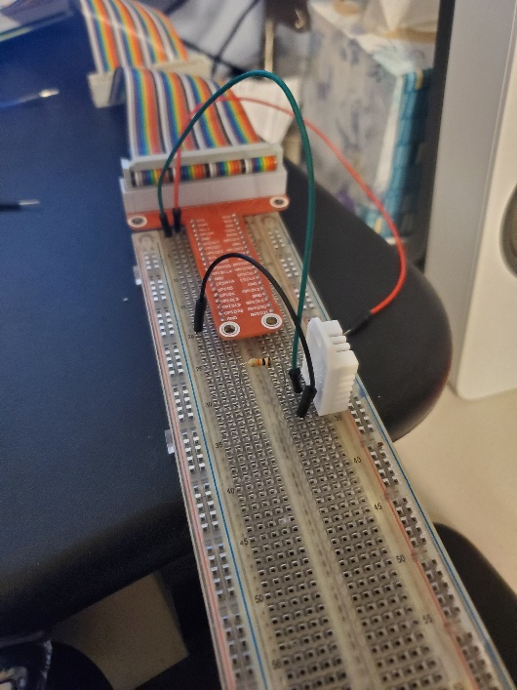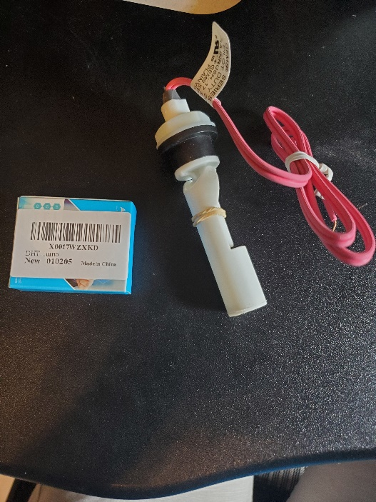

10:08

Resource for learning/using DHT22 humidity sensor: https://learn.adafruit.com/dht

liu 10:38 PM

checked